

Approved Product



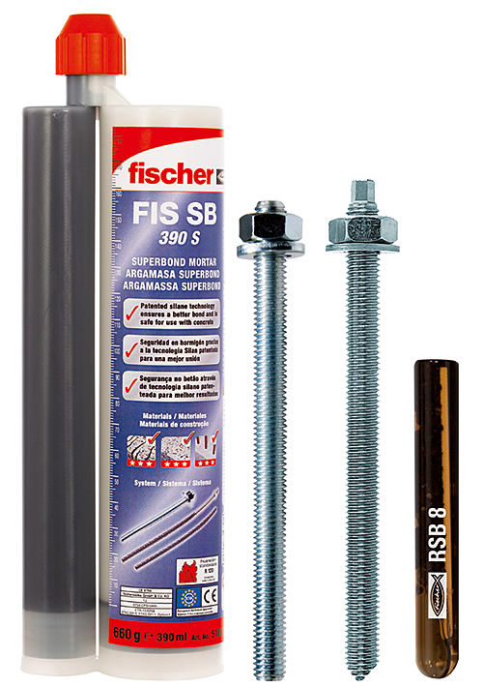

Superbond resin anchor FIS SB or RSB is suitable for structural safety critical anchoring of threaded anchor rods, internally threaded anchors or rebars in cracked or non-cracked concrete. Superbond resin anchor offer flexibility to the installers as the end user can choose between an injection resin FIS SB or resin capsule RSB. Injection mortar allows variable embedment depth, glass capsule system offer reduced curing times down to only 5minutes for temperatures above 20°C. Both systems can be used in dry or wet concrete, capsule can be installed also in flooded holes in accordance with Fischer’s installation procedures. Approved application temperatures are extended to 90°C for long term, 150°C for short term. Both systems can be used for fixing RG M or FIS A anchor rods, internally threaded anchor RG MI and FIS SB can be used also with rebar and rebar anchor FRA.

Case Study

Click Here

Branch Fider

Product Description

Approval Number

LUL Registration No. 2525



www.siginfrastructure.com



Approved Product



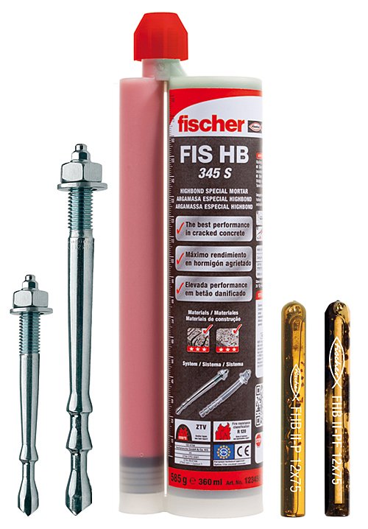

Torque controlled bonded anchor suitable for structural safety critical applications in cracked or non-cracked concrete. Highbond resin anchor FHB II is used to fix Highbond anchor rods FHB II AS and FHB II AL into cracked or non-cracked concrete. System offers flexibility as the end user can choose between an injection resin FIS HB 345 S, resin capsule FHB II P or fast cure capsule FHB II PF. Anchor can be installed in dry or wet drilled holes, capsule can be installed also in flooded holes in accordance with Fischer’s installation procedures. Anchor rods are available in various embedment depths so that optimised solution can be found. FHB II AS anchor rod allows through type installation with both injection and also glass capsule. FHB II PF capsule offers unique fast cure curing times of only 2minutes for temperatures above 20°C.

Case Study

www.sigri.co.uk

Click Here

Branch Finder

Product Description

Approval Number

LUL Registration No. 2526





Approved Product



C:\Users\nikolaidou-c\AppData\Local\Microsoft\Windows\Temporary Internet Files\Content.Word\P_P_RM001_F_#SALL_#APP_#V4.jpg

C:\Users\nikolaidou-c\AppData\Local\Microsoft\Windows\Temporary Internet Files\Content.Word\P_P_RGMI002_F_#SALL_#APP_#V1.jpg

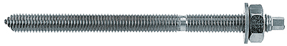

Resin bonded anchor R is vinyl ester glass capsule resin system suitable for structural safety critical anchoring of threaded anchor rods and internally threaded anchors in non-cracked concrete. It can be installed in dry, wet and also flooded drill holes in accordance with Fischer’s installation procedures. Systems can be used with both RG M anchor rods or internally threaded anchor RG MI

Case Study

www.sigri.co.uk

Click Here

Branch Finder

Product Description

Approval Number

LUL Registration No. 2527





Approved Product



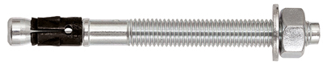

FAZ II is a high performance torque controlled expansion mechanical anchor suitable for structural safety critical steel connections in cracked or non-cracked concrete. Can be installed as a through fixing in accordance with Fischer’s installation procedures. Wide range of different diameters and lengths are available. Range offer standard and also reduced embedment depths and shorted FAZ II K anchors allowing to achieve value engineered solutions. Anchors are available in zinc plated, A4 stainless and also high corrosion resistant stainless steel.

Case Study

www.sigri.co.uk

Click Here

Branch Finder

Product Description

Approval Number

LUL Registration No. 2528





Approved Product



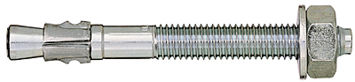

FBN II is a torque controlled expansion mechanical anchor suitable for structural safety critical steel connections in non-cracked concrete**.** Can be installed as a through fixing in accordance with Fischer’s installation procedures. Wide range of different diameters and lengths are available. Range offer standard and also reduced embedment depths allowing achieving value engineered solutions. Anchors are available in zinc plated and A4 stainless steel. Hot-dipped galvanised finish can be also offered but without ETA approval.

Case Study

www.sigri.co.uk

Click Here

Branch Finder

Product Description

Approval Number

LUL Registration No. 2529





Approved Product



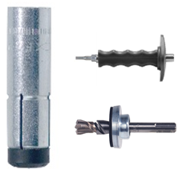

FZEA II is an undercut hammerset anchor with an internal thread suitable for structural safety critical steel connections in cracked or non-cracked concrete. Fixing is installed as a pre-positioned anchor directly into concrete in accordance with Fischer’s installation procedures. Undercut holes are drilled with FZUB drill bit. FZED plus setting tool is required for correct anchor setting. After correct installation, setting tool marks the sleeve of the anchor with impression marks, allowing easy installation safety check. Anchor is available in M8, M10 and M12 diameters in zinc plated, A4 stainless steel and also high corrosion resistance stainless steel. As this is a true undercut system, anchor and can be installed with small axial spacing and can be positioned close to free edges as per ETA specification.

Case Study

www.sigri.co.uk

Click Here

Branch Finder

Product Description

Approval Number

LUL Registration No. 2524





Approved Product



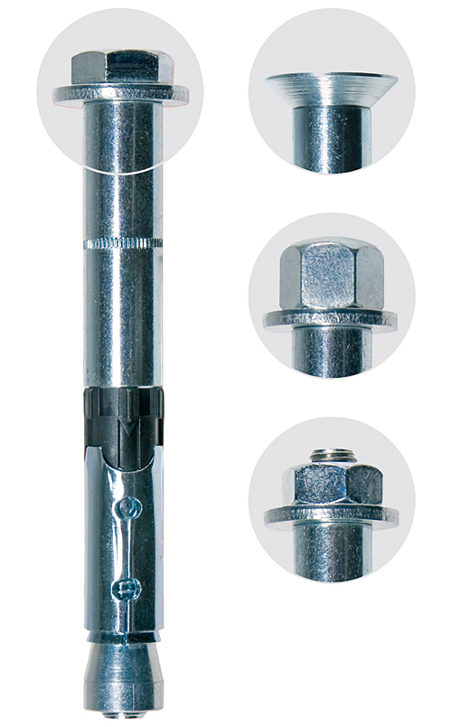 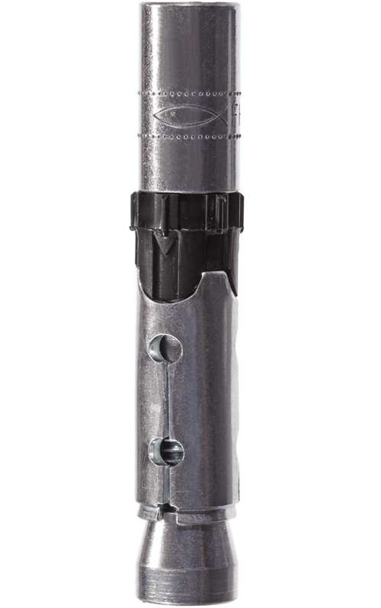

FH II is a high performance torque controlled expansion mechanical anchor suitable for structural safety critical steel connections in cracked or non-cracked concrete. Can be installed as a through fixing in accordance with Fischer’s installation procedures. Wide range of different diameters and lengths are available. Anchors are available in zinc plated and A4 stainless steel, with variety of different head types. Countersunk version FH II SK and internally threaded FH II-I are also available.

Case Study

www.sigri.co.uk

Click Here

Branch Finder

Product Description

Approval Number

LUL Registration No. 2530





Approved Product



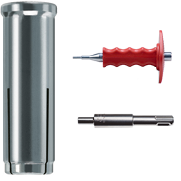

Deformation controlled expansion anchor suitable for structural steel connections in non-cracked concrete. Can be used also for multiple use for non-structural applications in cracked concrete.

EA II is a drop-in hammerset anchor with an internal thread for fixing into non-cracked concrete. Fixing is installed as a pre-positioned anchor directly into concrete in accordance with Fischer’s installation procedures. EAW H Plus or EA II S-SDS setting tool is required for correct anchor setting. After correct installation, manual setting tool marks the sleeve of the anchor with impression marks, allowing easy installation safety check. Anchor is available in M6-M20 diameters in zinc plated and A4 stainless steel.

Case Study

www.sigri.co.uk

Click Here

Branch Finder

Product Description

Approval Number

LUL Registration No. 2531





Approved Product



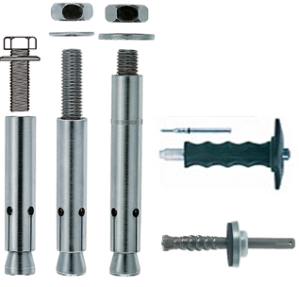

Zykon FZA is an undercut anchor suitable for structural safety critical steel connections in cracked or non-cracked concrete, offering the highest safety. Fixing is available as bolt projecting, through type or internally threaded type, allowing pre-positioned or push-through installation in accordance with Fischer’s installation procedures. Undercut holes are drilled with FZUB drill bit and correct setting tool is required for anchor setting. Anchor is available in wide range of diameters in zinc plated, A4 stainless steel and also high corrosion resistance stainless steel. As this is a true undercut system, anchor and can be installed with small axial spacing and can be positioned close to free edges as per ETA specification.

Case Study

www.sigri.co.uk

Click Here

Branch Finder

Product Description

Approval Number

LUL Registration No. 2532





Approved Product



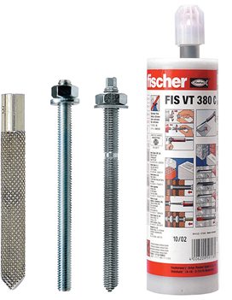

Injection resin FIS VT vinyl ester system is suitable for structural critical anchoring of threaded road and internally threaded anchors into non-cracked concrete or masonry. It can be installed in dry, wet and an anchor roads M12-M30 or RG MI anchors also in flooded drill holes in accordance with ETA and Fischer’s installation procedures. Systems can be used with both RGM and FIS A anchor roads or internally threaded anchor RG MI.

Case Study

|  |  |
| --- | --- |
|  |  |

www.sigri.co.uk

Click Here

Branch Finder

Product Description

Approval Number

LUL Registration No. 2529





Approved Product



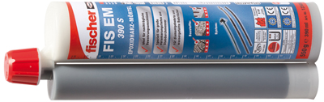

FIS EM is a high performance injection epoxy resin for structural connections of threaded studs and reinforcing bars to concrete and masonry. Product has ETA approval for cracked concrete and also ICC approvals are available.

Case Study

www.sigri.co.uk

Click Here

Branch Finder

Product Description

Approval Number

LUL Registration No. 1714





Approved Product



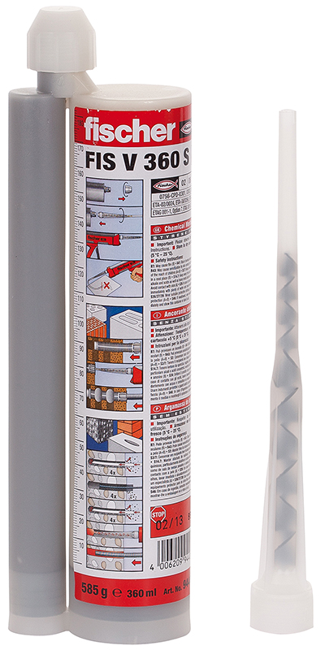

FIS V is a fast curing, high performance styrene free , hybrid vinyl ester resin. Suitable for connections such as metal studs or reinforcements bars into non-cracked concrete. Product has ETA approval.

Case Study

www.sigri.co.uk

Click Here

Branch Finder

Product Description

Approval Number

LUL Registration No. 1211





Approved Product



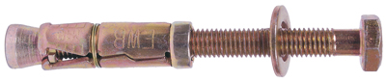 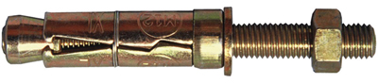

FWB is a traditional internally threaded segmented wall bolt for use in Brick high strength block and non-cracked concrete. Fixing is installed as a pre-installed installation. The shield finishes flush with the surface and can be combined with a bolt head , with thread and nut and washer or just the shield so that a standard metric threaded bold of the installer’s choice can be used. Anchors available only in zinc plated finish from M6 to M20 threads. The product meets the requirements of LU standard 1-085 and can be installed in sub-surface locations.

Case Study

www.sigri.co.uk

Click Here

Branch Finder

Product Description

Approval Number

LUL Registration No. 2609





Approved Product



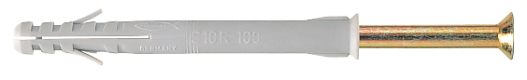

Fischer Insulator screw plug –Nylon S12 R100 is suitable for fixing conductor rail insulators to concrete sleepers.

Case Study

www.sigri.co.uk

Click Here

Branch Finder

Product Description

Approval Number

LUL Registration No. 1076





Approved Product



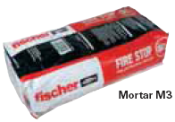

FFSC is a fire seal for service penetrations in walls and floors. This gypsum based Firestop mortar is supplied as a dry powder which is mixed with water prior to application.

Case Study

www.sigri.co.uk

Click Here

Branch Finder

Product Description

Approval Number

LUL Registration No. 356

